**RECOMMENDATIONS**

1. **Big Mountain resort should increase its ticket price to cover the additional operating cost of the new chair lift.**

Currently, Big Mountain resort is charging $81 for the ticket price. The model predicts the resort’s ticket price to be $95.87 with its current facilities compared to the market segment. Even taking into consideration the model error of about $10, there is still room for a ticket price increase. Although the current price of $81 is high in Montana, it is obvious that the resort’s facilities are very high up in the market segment (see graphs below). The total number of fast quads and runs are two features that are highly valued among skiers. It seems to be that the resort is not fully capitalizing on its facilities. Thus, the resort is underpricing with its current pricing strategy.

The ticket price can be increased gradually so that the resort’s price ticket can better reflect its facilities. The resort can increase this season’s ticket price by $2, which may bring the extra $3,500,000 revenue to fully cover the additional chair lift’s operating cost of $1,540,000.

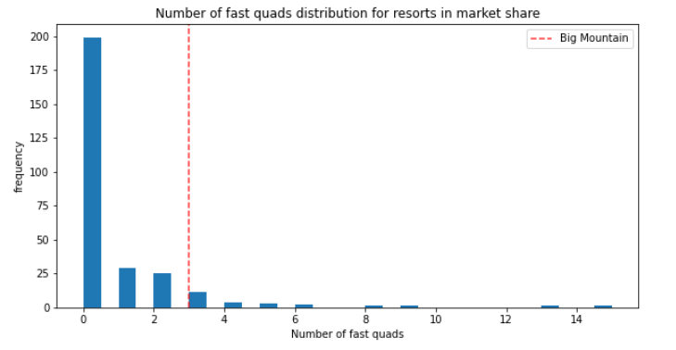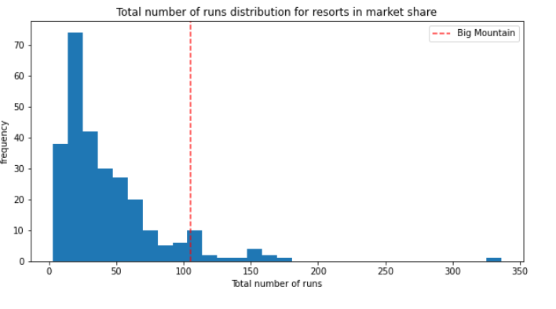

**2. The resort should close out 5 of its least used runs to reduce operating costs.**

Closing the resort’s 5 least used runs may reduce support for ticket price by $0.67. However, since the resort is already substantial underpricing, losing the support of $0.67 would not make the resort to reduce its current price. The current price is still sufficiently supported by the reduced facilities. This approach can be quickly applied to help the resort cut cost in order to compensate for the additional chair lift’s operating cost. However, we will need more information about the operating cost and usage rate by visitors to test for any possible run closures.

**3. Big Mountain resort can create further support for a price increase by adding additional facilities to the skiers.**

The model searched for features that are highly valuable to skiers. Those features include the total number of runs, the total number of chair lifts, and vertical drop (see below graph). By adding an additional run, increasing the vertical drop by 150 feet, and installing an additional chair lift for commuting, the modeled ticket price is increased by $1.99. The total revenue could amount to $3,500,000 with the new facilities. This approach is suitable to use if the resort aims to further increase its ticket price in the future when the ticket price is already accurately set to fully capitalize the facilities.

